# **Binary Classification**

# **Multi-class Classification**

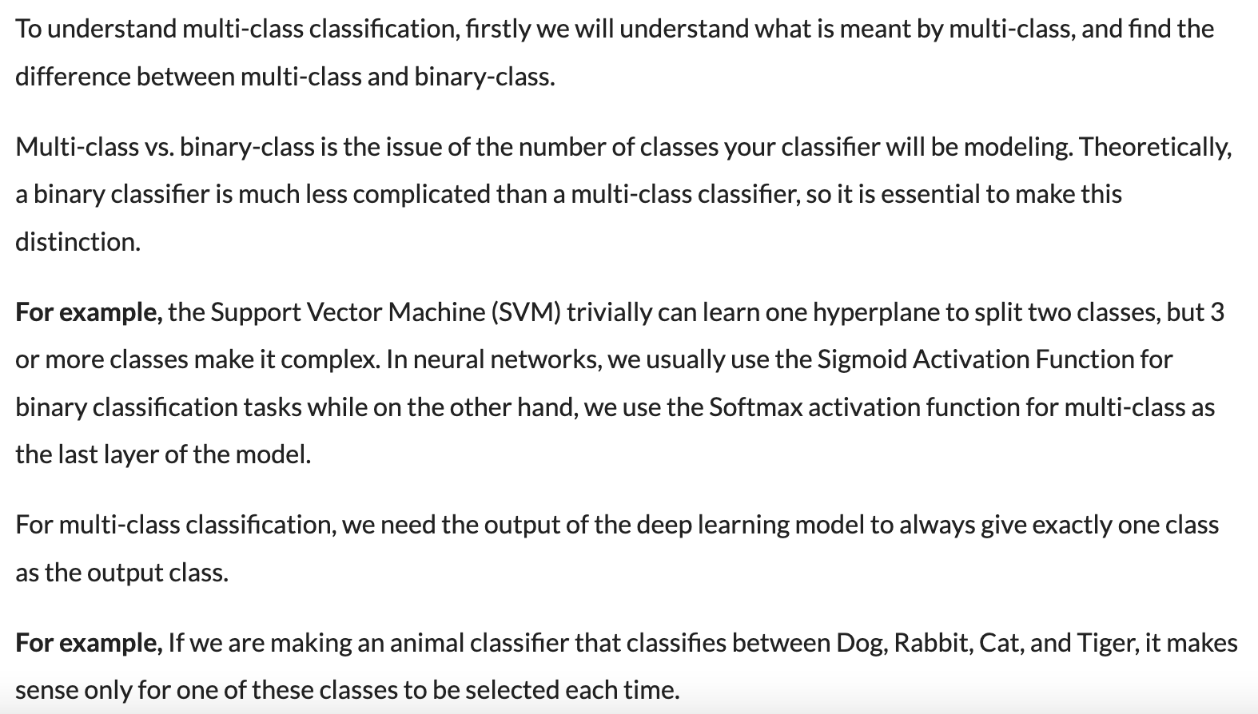

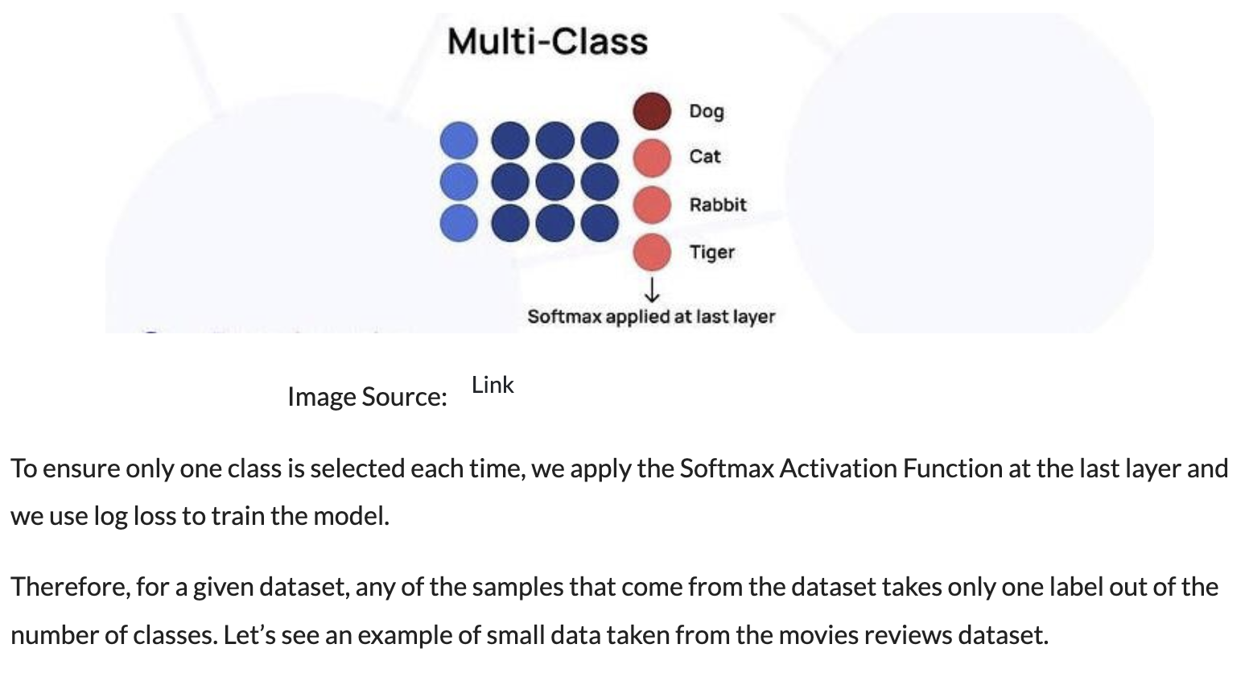

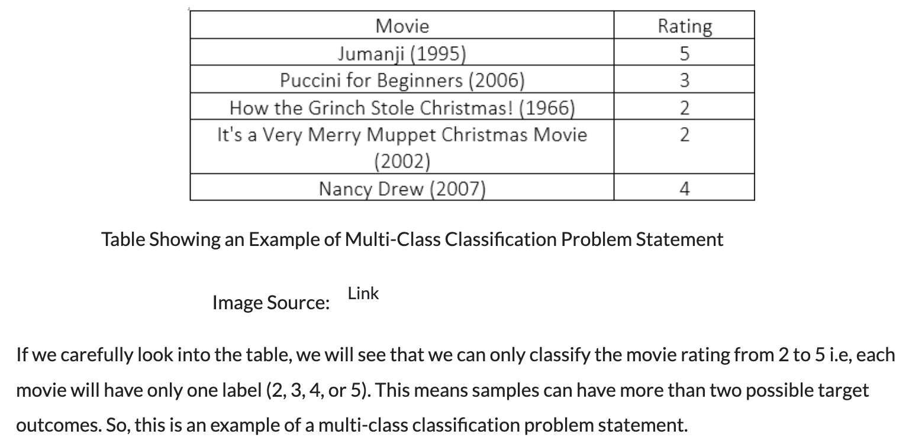

# **Multi-label Classification**

# **Difference in Real-life example**

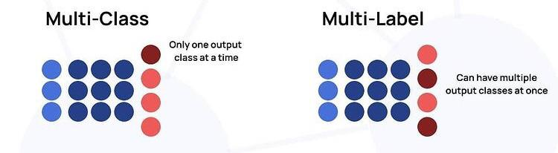

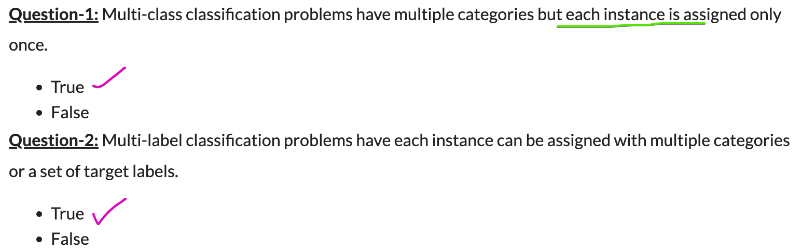

# **References**

[Difference between Multi-Class and Multi-Label Classification (analyticsvidhya.com)](https://www.analyticsvidhya.com/blog/2021/07/demystifying-the-difference-between-multi-class-and-multi-label-classification-problem-statements-in-deep-learning/)